Dancing Men Code Translator

There are sets of characters, ones with and ones without flags. The characters holding a flag in one hand mark the last letters of words. The last letter of the last word may or may not have a flag.

Main Characters without Flags
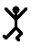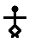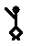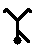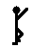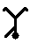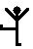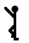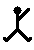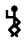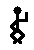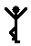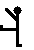
A B C D E F G H I J K L M N O P

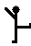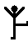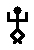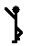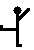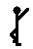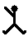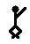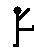
Q R S T U V W X Y Z

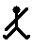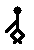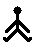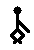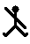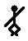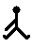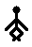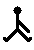
1 2 3 4 5 6 7 8 9

Main Characters with Flags
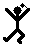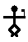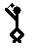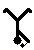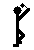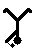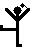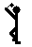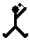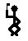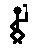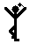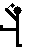
A B C D E F G H I J K L M N O P

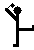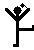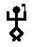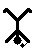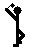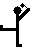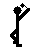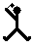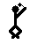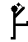
Q R S T U V W X Y Z

Vocabulary

(2) Malodorous: Foul, bad smelly; stench

(2) Meretricious: plausible but false or insincere

(3) Conundrum: a riddle in which a fanciful

(3) Florid: flushed with rosy color

(3) Grotesque: bizarre or outlandish

(4) Allude: to make an indirect reference

(5) Hieroglyphics: a system of writing using pictorial symbols to represent meanings or sounds

(8) Convulsive: an uncontrolled fit

(11) Melancholy: sadness or depression of spirits, gloom

(11) Porticoed: a porch or walkway with a roof supported by columns leading to an entrance

(13) Inexorable: incapable of being persuaded, relentless

(13) Stolid: having or revealing little emotion

(15) Guttered: to melt away through the side of a hollow formed by burning wide

(15) Capitall: first rate, excellent; a capital idea

